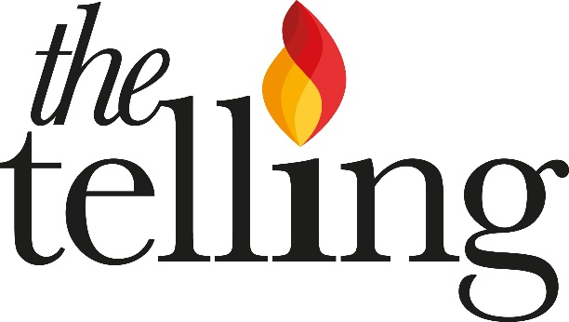
Concerts - but not as we know them

Clare Norburn, Director
22c Drylands Road London N8 9HN
020 8351 2838 07587 875922
clare@thetelling.co.uk clare.noburn@outlook.com www.thetelling.co.uk

Gift Aid Declaration Form
The Telling is a registered charity no 1181802. As a small charity, we’re so grateful for your support! Thank you. Gift Aid allows us to claim back 25p of tax for every £1 you (as a UK taxpayer) give, making your donation go further.

Please complete this form by hand if posting or we won’t be able to claim Gift Aid on it.

- Your name and address is needed to identify you as a current UK taxpayer. This declaration is not valid without it

Title _______ Forename ________________________ Surname ___________________________

Address ___________________________________________________________________________

Postcode ________________________ Email address: ______________________________________

- In order to Gift Aid your donation you must also tick the box below and sign and date:

I want to Gift Aid this, my current donation of £______________ and any donations I make in the future or have made in the past 4 years to The Telling (registered charity no 1181802)

I am a UK taxpayer and understand that if I pay less Income Tax and/or Capital Gains Tax than the amount of Gift Aid claimed on all my donations in that tax year it is my responsibility to pay any difference

Signature: ________________________________________ Date: _____________________
Please return this completed form to the address above

Notes Please remember to let us know of any changes to your tax status including changes to your name or address or if you need to cancel this agreement. You can cancel the declaration at any time by contacting us using the email, phone and postal address above. If you are not sure whether your donations qualify for tax relief please call us.

KEEPING IN TOUCH: Under GDPR we need to let you know that we will write to you to tell you about our work and how your donation has made a difference - and how you can donate and help in other ways, as well as to update you about our news and services. If you would rather we didn’t communicate with you in this way, you can change the way we contact you at any time by emailing clare@thetelling.co.uk writing to the address above or calling the phone numbers above.

For full details of our privacy policy, please visit https://www.thetelling.co.uk/privacypolicy

